| **Test Name** | | | Test rolling produces new results | | | |
| --- | --- | --- | --- | --- | --- | --- |
| **Use Case Tested:** | | | Play Game | | | |
| **Test Description:** | | | Tests that each roll is producing new results, and we don’t get the same result every roll, and every game, in each run of Main.java. | | | |
| **Pre-conditions** | | | No pre-conditions (first bug to be investigated and resolved, as it is a pre-requisite to properly replicate the other bugs). | | | |
| **Post-conditions** | | | Not every roll is identical. | | | |
| **Notes:** | |  | | | | |
| **Result (Pass/Fail/Warning/Incomplete)** | |  | | | | |
|  | **TEST STEP** | | | **EXPECTED TEST RESULTS** | P | F |
|  | Run Bug4Replication.java | | | Console opens and results for 100 games are displayed in it. Only the rolls are shown (i.e. only lines of the form, “Rolled DIE1, DIE2, DIE3” where DIE1, DIE2, and DIE3 are one of the available faces CROWN, ANCHOR, SPADE, HEART, DIAMOND, CLUB), no details about bets or balances. |  |  |
|  | Look at each individual line | | | There are at minimum two different rolls. |  |  |
|  | Repeat Steps 1-2 twice (for three runs total). | | | Same as Steps 1-2. |  |  |

|  |  |  |  |  |  |
| --- | --- | --- | --- | --- | --- |
| **Test Data Table** | | | | | |
|  | **1** | **2** | **3** | **4** | **5** |
| N/A |  |  |  |  |  |

# Results

## Run 1

Full results can be found at Bug4ReplicationSample1.txt (a copy-paste of the entire console output).

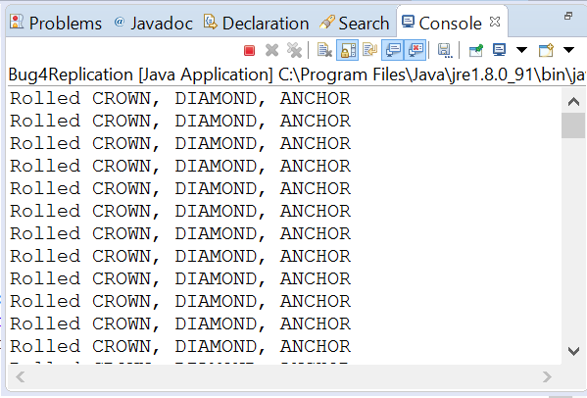

## Run 2

Full results can be found at Bug4ReplicationSample2.txt (a copy-paste of the entire console output).

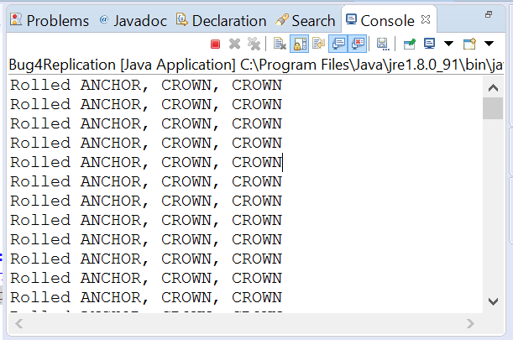

## Run 3

Full results can be found at Bug4ReplicationSample3.txt (a copy-paste of the entire console output).

